Homework for Class 1: Preparing Your Competitive Book List

- In a Word doc or docx file, put this section’s title and your last name in 20 point type on the top left of the page. Save the file under that name.

Example: Competitive Book List - Jones.docx

- Start with a short paragraph (less than 300 words!) on what your book is about. Only that! Not why you wrote it nor who you are or anything else.

- In that Word doc/docx file (no Macs in publishing!), write down the few sentences you worked on before we began that describe your book in general.

- Next, meticulously list 6-8 books that most closely compete with your proposed work. This is information should be in this format:

Book Title / subtitle by Author’s Name(s) (Publishing House, Year Released) – Amazon Ranking today

EXAMPLE:

Good to Great: Why Some Companies Make the Leap and Others Don’t by Jim Collins (HarperBusiness, 2001) Amazon Ranking 1,292

NOTE: This document will form the base of an important part of your proposal. To save yourself a lot of hassle and time later, make sure your information is precise. ALWAYS use the hardcover statistics; if those are unavailable, use the paperback numbers. Not audio, Kindle or other formats.

- Buy at least one book from your list and start reading it today, in any format, used or new, digital or print.

- Upload the file to the portal so that our editors can double check it. When you get their approval buy or borrow those books and start reading them NOW. In a few weeks, you’ll be really glad you did. Make sure you do this important first step if you want to finish your proposal on time.

Do NOT skip this first deadline!

How to select the right books:
Using key words associated with your book, search Amazon.com in your country of residence and Amazon.com US (if you can access it) for books similar to yours.
- For example: A sales book require search words like “Sales, Selling more, increasing sales…”
- For example: A memoir might include words like “Cancer survivor, child abuse memoir, overcoming adversity…”
- For example: A parenting book might include words like “Parenting difficult teenagers, parenting, adolescents at risk…”
For each title that seems like it might be similar, scroll down until you see its sales ranking. That section is about 2/3 down the page and looks like this:
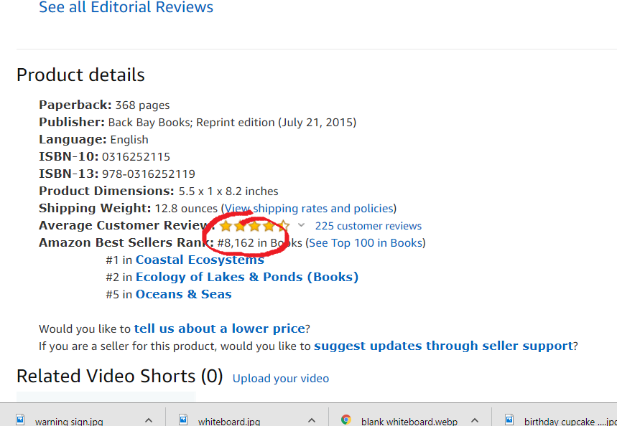

A WORD OF ADVICE:
ONLY consider books whose current Amazon ranking is between 1 – 150,000. Anything above that is not selling well, so it is not competitive with your book. If ALL the books similar to yours are higher than 150,000, it’s a sign you may wish to broaden your content to achieve NDBM. Low sales of competing books are already an indication that your book may not be well-received by publishers because books like it are not selling well right now.

What to do once you have an idea of which books compare best:
Once you have selected 6-8 books that are the closest you can find/are similar to yours, you need to read some or all of the content in each of them to find out what’s good and bad about those books. Ask yourself these questions and take notes as you gather the answers.
- What’s great about this book?
- How qualified is the author?
- What’s bad about this book?
- What did he/she miss?
- What did she/he add that you should also remember to include?
- How well is it written?
- Is it too easy or too hard to read? Why?
- Do you like the writer’s style?
- Do you feel like you can trust the writer?
- Does the writer know her stuff as well as I do?
- Does the writer talk down to the reader?
- Anything else that makes you enrich your NDBM idea

Do this in the background of the course and TAKE METICULOUS NOTES!
You’ll need to repeat this process for all 6-8 books over the course of this workshop, so don’t waste time. For now, we recommend that you start with the one book that is most similar to yours.
YOUR NOTES WILL BE INVALUABLE LATER, so be precise with them now. Failure to do this may cause you to be delayed on finishing your proposal. There are many reasons this is the first step to a successful proposal.
Go! Start!

